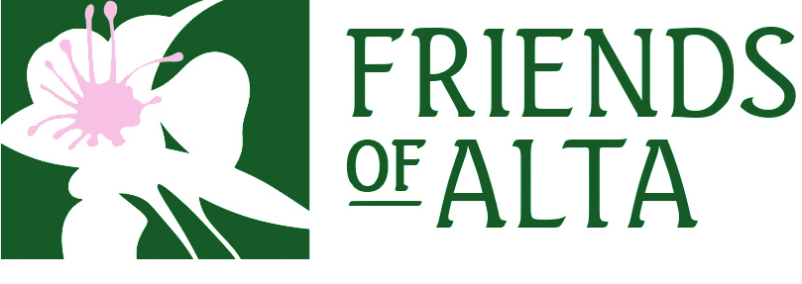
Job Title: Bill Levitt Fellowship
Position: Temporary, full-time, hourly, nonexempt
Reports to: Executive Director Summer

Mission:
As Alta’s local land trust, the Mission of Friends of Alta is to protect the environment of Alta, including watershed and wildlife habitat areas; to preserve Alta’s unique character and heritage; and to encourage stewardship and sustainability of Alta’s environment and community.
Position Summary:
The summer fellowship mainly consists of environmental stewardship work, scientific data collection, and outreach with the public. The following tasks further describe the regular duties to be performed by a fellow as he/she serves under the supervision and direction of the Executive Director (ED) of Friends of Alta.
Tasks:
- Represent FOA at summer stewardship events such as: Wasatch Wildflower Festival, Invasive Weed Pulls, Alta volunteer day, Kids Day, and Memorial Tree & Seedling Planting. Possible other FOA specific events throughout the summer.
- Alta Bird Events / Maintenance
  - Maintain Hummingbird Feeding Station
  - Participate in other birding events such as TA Bird Talk and Walk
- Alta Summer Host: at the Albion Grill or Cecret Lake Trailhead
  - Host the booth one weekend day each week and possible holidays.
  - Provide naturals information to summer visitors
- Invasive weed removal: documentation using GPS/GIS and remove invasive weeds in designated area.
- FOA Conservation Easement Monitoring Program – property site inspections and documentation
- Assist the ED with office and/or special research projects as needed

Qualifications:
- Computer skills including: Microsoft Office Programs, email, and internet
- Ability to work independently, and as part of a team
- Good interpersonal and communication skills are a must
- Ability to positively interact with a broad public
- Ability to conduct strenuous work outdoors in variable conditions
- Experience working in the outdoors
- Availability to work a variable schedule
- Current driver’s license
- Ability to demonstrate eligibility for work in the United States

Working Conditions:
- Working, educating, and interacting with a broad public
- Heavy physical activity. Required to push, pull or lift medium weights, and to stand, sit or walk outdoors for extended periods
- Exposure to extreme heat, cold, dampness, elevation extremes and occupational hazards as may be expected when working in mountainous areas
- Considerable trail hazards
- Requires physical ability to access remote alpine areas by foot
Physical Requirements:
- Ability to sit for long periods of time while also performing typing duties on a computer
- Ability to stand for long periods of time
- Ability to conduct strenuous work indoors and outdoors in variable conditions
- Ability to lift, bend, stoop, kneel, crouch, push and other strenuous activities
- Ability to lift and carry objects of at least 50 pounds
Schedule:
- Seasonal/Temporary Position: June/July to September 2023
- 20-30 hours per week (non-exempt position). Hours negotiable.
- Variable schedule
- Holiday and one weekend day work required
- Some evenings may be required
Pay & Internship Credit:
- $10.00/hour paid biweekly
- University internship credit may be available upon request

At-Will Employment:
All employees working for Friends of Alta (FOA) are at-will employees meaning that either they
or FOA may terminate the relationship at any time, for any reason, with or without notice. No
communication, oral or written, may change that status unless it is done so in writing and
submitted and approved by your supervisor.

To Apply:
Please email a cover letter, resume, and contact information for three references as one document to Kody Fox at kody@friendsofalta.org. Title the document with your last and first name like this: Fox-Kody_2023BLF-APP.pdf. A draft schedule is available upon request.

Please contact Kody Fox with any additional questions at kody@friendsofalta.org or at 435-650-1449

