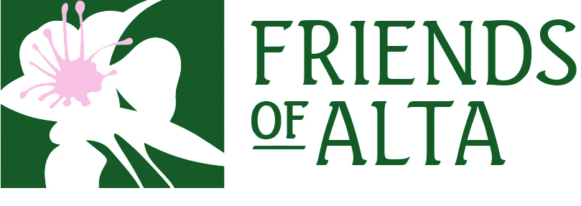
Job Title: Board of Directors

Purpose & Mission:
The purpose of Friends of Alta is to protect our natural resources for generations to come. This allows the agency to partner with local, state and national agencies, nonprofit organizations and individuals who share a commitment to conservation.
Our mission is to protect and preserve Alta’s unique environment, heritage and character.
Our work is based on these core values:
- Alta is a small but vibrant mountain community of people and businesses. We value the diversity and independence of the businesses that call Alta home. We are committed to sustaining the local economy.
- Alta is a critical ecosystem whose benefits extend far beyond Little Cottonwood Canyons. We devote tactical and strategic resources to protecting the watershed and Albion Basin.
- We base our work on science and research. We are experts in where development can take place in Alta, and are diligent stewards of the land.
- We are future oriented. We know that Alta will change over time. However we believe that the inevitable changes that the future brings can occur with transparency in decision making, respect for the recreational base of our local economy, and the preservation of this unique place on earth.
Alta is a state of mind as well as a place on earth. We are accountable to all who call Alta home, whether for a week spent skiing every year, a summer’s day, or a lifetime. We also share responsibility with others for preserving the watershed that all residents of the Salt Lake Valley rely on every day.
This is a complex set of responsibilities. Therefore partnerships, land trust, public advocacy, strategic legal recourse, science and educational programs are each an important part of our competitive advantage.
Skills & Talent:
- For board members, we're currently looking for candidates with core competencies in finance/ capital campaign, community development/marketing, and legal professionals.
- Assurance that he/she has the time and interest to be engaged and active.
- Credible individual with knowledge of and influence in the community.
- Potential for future leadership role on Board.
- Intention of making Friends of Alta a high priority for personal financial giving
- Willing to leverage personal and professional social capital to promote Friends of Alta mission.
- Commitment to the Friends of Alta; its values and an understanding of its objectives, organization, services, and the responsibilities and relationships of working with donors, volunteers and partner
Meeting Frequency: Varies per month, includes regularly scheduled board meetings, committee meetings, and special events
- Board Meetings- Once a quarter (4 times a year) for 2 hours
- Sub-committees- varies, some meet monthly for an hour and some meet quarterly for an hour. There are 7 sub-committees that the board member can choose from. Although no sub-committee choice is required it is highly recommended.
Overall Time Commitment: Approximately 2 hour per month
Financial Commitment: No minimum financial donation required per a year but FOA should be one of the higher donation choices per a year. You can either make the donation yourself or recruit other individuals to make a donation to FOA.
Position Summary:
As the highest leadership body of the organization and to satisfy its fiduciary duties, the board is responsible for-
• ensuring that FOA adheres to the mission, vision, and values of the organization
• selecting and evaluating the performance of the Executive Director
• strategic and organizational planning
• ensuring strong fiduciary oversight and financial management
• fundraising and resource development specifically toward the goals of FOA
• approving and monitoring FOA’s programs and services
• enhancing FOA’s public image
• assessing its own performance as the governing body of FOA
Location:
Virtually and in person in Alta, UT
To Apply:
Please contact Kody Fox and Richard Thomas.
Kody Fox: kody@friendsofalta.org or at 435-650-1449
Richard Thomas: rsthomas@friendsofalta.org or at 801-944-0080

