Ellie Johnson Internship Evaluation & Reflections
Working as the Bill Levitt Fellow for the last 6 months has been a positive experience. My time with Friends of Alta has developed my professional skills as well as strengthened my connection with Alta as a place and a community. The skills I’ve learned through this fellowship will be useful as an environmentalist in and out of the workplace. I leave FOA in hopes other interns will have the positive experience I did and the organization may continue its conservation efforts.
The summer started off just as I had hoped, with a lot of time in the field. I hiked all across the ridgelines and basins of Alta gathering data for our Breeding Bird Survey and the Forest Health Assessment. Having lunch under the shade of a 500 year old limber pine, soaking up the sun in fields of wildflowers, and startling a gaggle of pygmy owls during a summer monsoon were a few memorable moments. It was during times like that I would think “am I really getting paid for this?” I think of this fellowship as a good reminder of what kind of career I’d like to strive toward, that is working in the environmental science of the natural world. The weeks flew by, the more I learned the more I loved.
I was able to network with environmental organizations, departments within Alta, and the visitors to the Albion Basin. Our public events and outreach efforts were valuable. They allowed me to communicate with a variety of people from the valley and share what I know about the place and our efforts to protect Alta. This was a valuable time for me to practice my communication skills. It was the first time I felt like I was applying knowledge from my minor in communications professionally.
My connection to Alta deepened with a greater understanding of the mining history, the ski resort, and the town. I gained an appreciation of where Alta started from and where it might go. I came to realize just how developed the area had become during its early establishment and what a toll that took on the environment. I discovered “Witness Trees” along the ridge while hiking around the Supreme area. These trees have numbers carved into their trunks to mark boarders in compliance with the Homestead Act in the late 1800s. For me, these trees symbolize the beginning of expansion and exploitation of Little Cottonwood Canyon. After the mining boom Alta transitioned to a more sustainable recreational platform. However, it makes me realize the important role the Alta Environmental Center, Town of Alta and Friends of Alta play in keeping a balance between business and wilderness, “fighting the good fight” so to speak.
I am grateful for the flexible scheduling which allowed me to continue my work in The Grand Canyon and survey for a land trust in the Alpine, a perfect dichotomy. The work load matched the expectations outline presented at the begging of the fellowship. I always felt well supported and informed by the FOA staff. I thank Mimi, Jen, Stella, Christine, Maura and T for their mentorship.
While my time here has been positive overall, I wish I had experience in some areas. I wasn’t able to work on the Wetland Study because timing of the Forest surveys. I think that would have been a valuable project to be a part of because of my interest in Watershed Science. Although, attending the Watershed Symposium for Friends of Alta will add to my repertoire. Furthermore, I wish I had the chance to participate in the data entry and analysis. To follow up on the data and learn about processes after data has been collected would be useful experience. However, I was able to brush up on technical skills by using excel, publisher, and writing professional emails while working in the office. This was something unexpected, yet welcome.
In Reflecting upon my experience over the last six months I feel grateful to have been able to contribute to so many different aspects of what is Alta. To name a few: vegetation surveys, weed surveys, forest health assessments, seedling survival studies, community events, tree planting and transplanting, naturalist hosting, farmers market and watershed symposium tabling. This internship is unique in that it gives the intern a variety of projects to be a part of while being flexible with their individual needs. I am happy to have been a small contributing piece of what makes Alta worthy of conservation.
A Rainy Day Looking Down Grizzly Gulch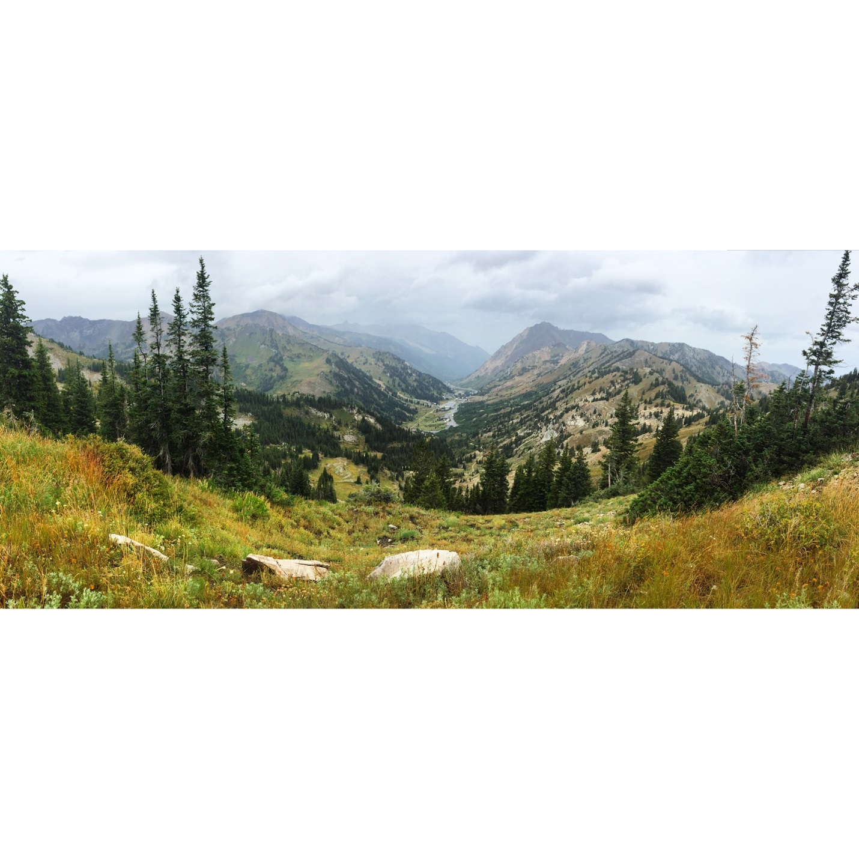
Wild Life Sightings
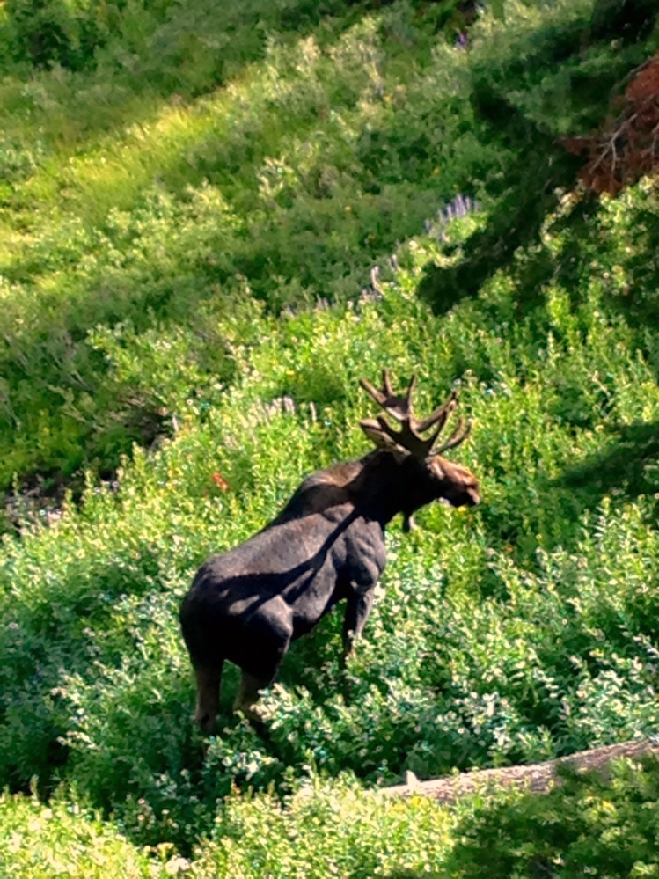

Witness Trees
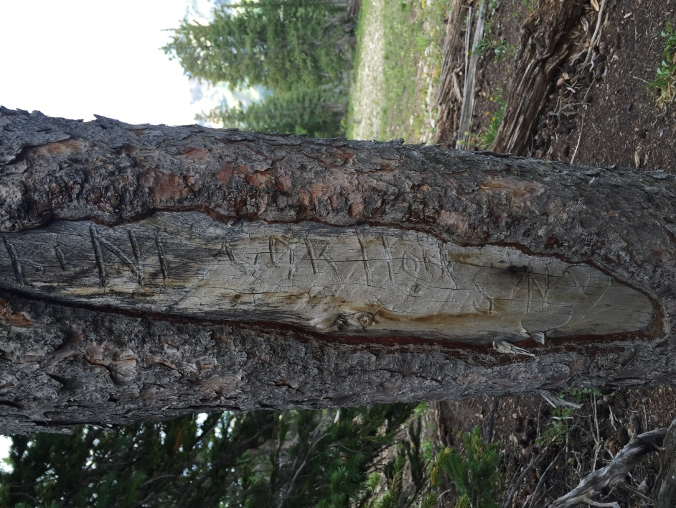
Wild Flowers on High Greely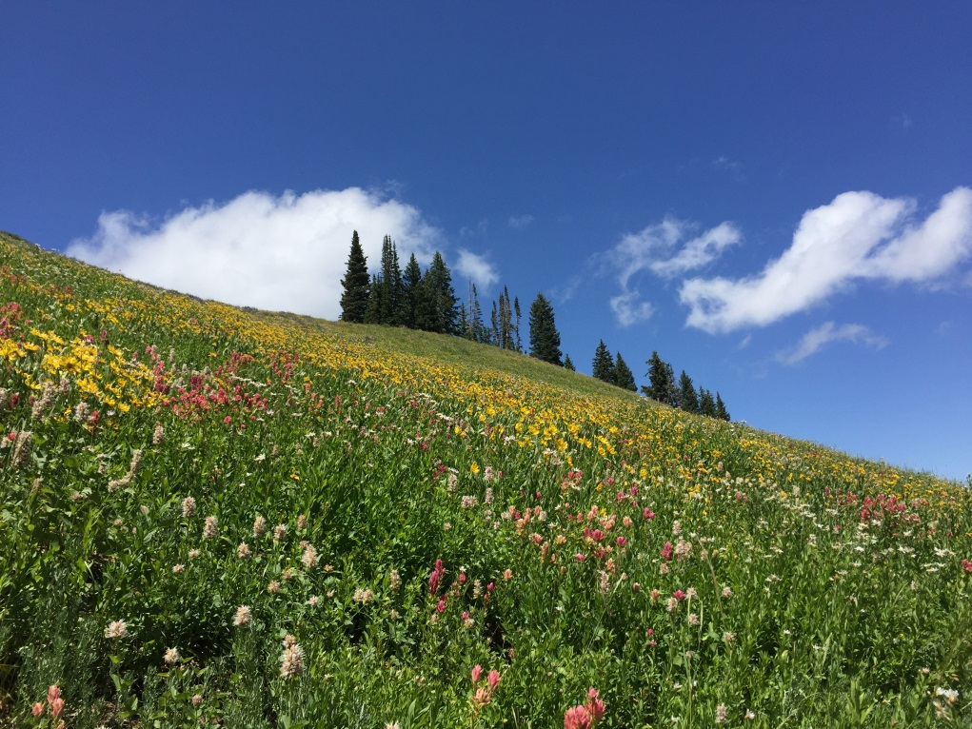
Small Surveyor, Big Mountains